A. KPI’s
1. Total Revenue
SELECT SUM(total_price) AS Total_Revenue FROM pizza_sales
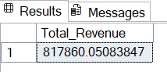
2. Average Order Value
SELECT SUM(total_price) / COUNT(DISTINCT order_id) As Avg_order_value FROM pizza_sales
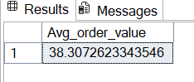
3.Total Pizzas Sold
SELECT SUM(quantity) AS Total_Pizza_Sold FROM pizza_sales
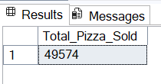
4. Total Orders
SELECT COUNT(DISTINCT order_id) AS Total_Orders FROM pizza_sales
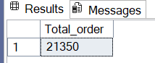
5. Average Pizzas Per Order
SELECT CAST(CAST(SUM(quantity) AS DECIMAL(10,2)) /
CAST(COUNT(DISTINCT order_id) AS DECIMAL(10,2)) AS DECIMAL(10,2)) AS Avg_pizzas_per_order FROM pizza_sales
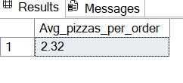
B. Daily Trend for Total Orders
SELECT DATENAME(DW, order_date) AS order_day, COUNT(DISTINCT order_id) AS Total_order
FROM pizza_sales
GROUP BY DATENAME(DW, order_date)
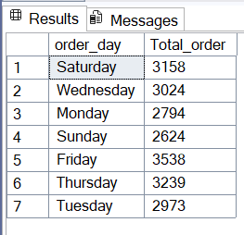
C. Monthly Trend for Orders
SELECT DATENAME(MONTH, order_date) AS Month_Name, COUNT(DISTINCT order_id) AS Total_order
FROM pizza_sales
GROUP BY DATENAME(MONTH, order_date)
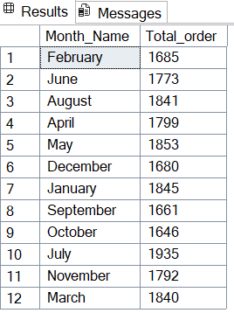
SELECT DATENAME(MONTH, order_date) AS Month_Name, COUNT(DISTINCT order_id) AS Total_orders
FROM pizza_sales
GROUP BY DATENAME(MONTH, order_date)
ORDER BY Total_orders DESC
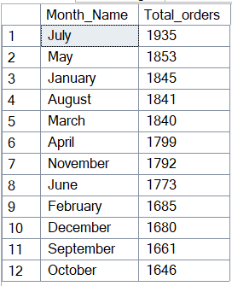
D. % of Sales by Pizza Category
SELECT pizza_category, SUM(total_price) AS Total_sales, SUM(total_price) * 100 / (SELECT SUM(total_price) FROM pizza_sales) AS PCT
FROM pizza_sales
GROUP BY pizza_category
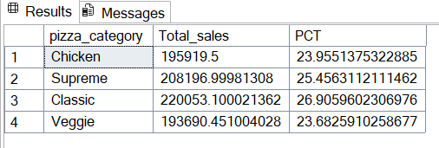

E. % of Sales by Pizza Size
SELECT pizza_size, SUM(total_price) AS Total_sales, SUM(total_price) * 100 / (SELECT SUM(total_price) FROM pizza_sales) AS PCT
FROM pizza_sales
GROUP BY pizza_size
ORDER BY PCT DESC
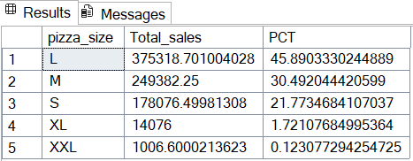
SELECT pizza_size, SUM(total_price) AS Total_sales, CAST(SUM(total_price) * 100 / (SELECT SUM(total_price) FROM pizza_sales) AS DECIMAL(10,2)) AS PCT
FROM pizza_sales
GROUP BY pizza_size
ORDER BY PCT DESC
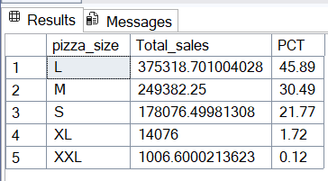
SELECT pizza_size, CAST(SUM(total_price) AS DECIMAL(10,2)) AS Total_sales, CAST(SUM(total_price) * 100 / (SELECT SUM(total_price) FROM pizza_sales WHERE DATEPART(quarter, order_date) = 1) AS DECIMAL(10,2)) AS PCT
FROM pizza_sales WHERE DATEPART(quarter, order_date) = 1 GROUP BY pizza_size
ORDER BY PCT DESC
F. Top 5 Pizzas by Revenue
SELECT TOP 5 pizza_name, SUM(total_price) AS Total_Revenue FROM
pizza_sales
GROUP BY pizza_name
ORDER BY Total_Revenue DESC
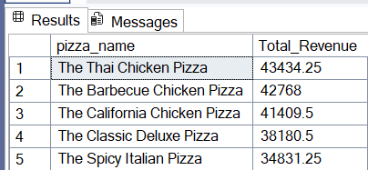
G. Bottom 5 Pizzas by Revenue
SELECT TOP 5 pizza_name, SUM(total_price) AS Total_Revenue FROM
pizza_sales
GROUP BY pizza_name
ORDER BY Total_Revenue ASC
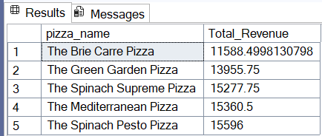

H. Top 5 Pizzas by Quantity
SELECT TOP 5 pizza_name, SUM(quantity) AS Total_Quantity FROM
pizza_sales
GROUP BY pizza_name
ORDER BY Total_Quantity DESC
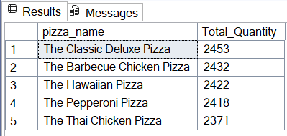
I. Bottom 5 Pizzas by Quantity
SELECT TOP 5 pizza_name, SUM(quantity) AS Total_Quantity FROM
pizza_sales
GROUP BY pizza_name
ORDER BY Total_Quantity ASC
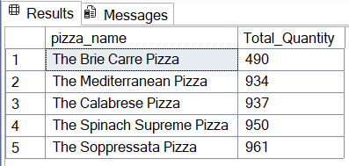

J. Top 5 Pizzas by Total Orders
SELECT TOP 5 pizza_name, COUNT(DISTINCT order_id) AS Total_Orders FROM
pizza_sales
GROUP BY pizza_name
ORDER BY Total_Orders DESC
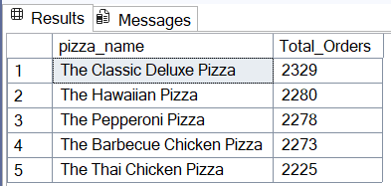
K. Borrom 5 Pizzas by Total Orders
SELECT TOP 5 pizza_name, COUNT(DISTINCT order_id) AS Total_Orders FROM
pizza_sales
GROUP BY pizza_name
ORDER BY Total_Orders
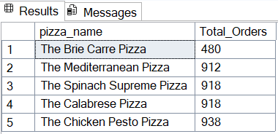

NOTE
If you want to apply the pizza_category or pizza_size filters to the above queries you can use WHERE clause. Follow some of below examples
SELECT Top 5 pizza_name, COUNT(DISTINCT order_id) AS Total_Orders
FROM pizza_sales
WHERE pizza_category = 'Classic'
GROUP BY pizza_name
ORDER BY Total_Orders ASC

